05/05/2022 第十二週 線上教室

今天繼續介紹Obamacare平價醫療法立法過程民主黨如何運用超級多數壓制少數黨，並於喪失參院超級多數後如何以預算劃一程序最終完成立法的案例。

四、財政委員會六人小組

6月17日參議院衛生、教育、勞工、退休金委員會開始討論醫改法案的第一天，參院財政委員會主席Max Baucus邀集了委員會兩黨委員7人，開始在其辦公室每日開會討論醫改案相關的各種問題。除主席Baucus、共和黨高階委員(ranking member) Chuck Grassley(IA)以外，民主黨委員包括Jeff Bingaman (NM)、Kent Conrad(ND)，共和黨包括Olympia Snowe(ME)、Mike Enzi(WY)、Orrin Hatch(UT)等人，由於Hatch僅在初期6、7月間參與討論，媒體僅稱之為「六人小組(Group of Six)」或「六人幫(Gang of Six)」。六人小組每天開兩次會，上午10:00討論到中午，下午2:30繼續，每天的會議均持續數小時。以政治光譜而言，民主黨三人加上共和黨的Snowe均為中間派，共和黨另外兩人為保守派，六人小組反映出參議院中間偏右的立場，相當程度上與民主黨自由派的主流偏離。

主席Baucus召集六人小組的目的，在設法型塑出跨兩黨支持的醫療改革立法，若能獲致跨兩黨協議(bipartisan deal)，此一版本勢必會比衛生委員會與眾議院其他版本的醫改案較為保守派右傾。因此在其他版本中，為歐巴馬與自由派支持的政府公營醫療保險參與保險市場競爭的方案(Public Option)，遂遭六人小組排除。小組對禁止保險公司因個人既往病史拒保、對醫療費用高昂的慢性病治療加強管理等政策目標均有共識，但是在醫改立法新增的經費應如何支付上，小組內部意見陷入嚴重的分歧。

由於歐巴馬與兩院領導階層乃至眾議院民主黨保守派選區的議員，都在等待六人小組的跨兩黨協議，因此原本歐巴馬期望在國會八月休會之前通過醫改案的時程必須順延至九月國會復會以後了。

五、歐巴馬治療與茶黨

2009年8月至9月初國會休會五週，民主黨議員及歐巴馬本人分赴全美各地舉行550場以上的醫改鎮民大會 (health care town hall meetings)，藉著直接與選民接觸、說明醫療改革法案的機會，希望能在9月國會開議之前動員各地民眾支持歐巴馬的醫改立法，以便創造氣勢，下一步在兩院院會審議時能順利通過。 8月在全美各地舉行的醫改鎮民大會，不但動員了各地自由派民眾支持醫改立法，同時也挑起了保守派的反對聲浪，其中最引人注目的就屬各地的茶黨(TEA Party)。

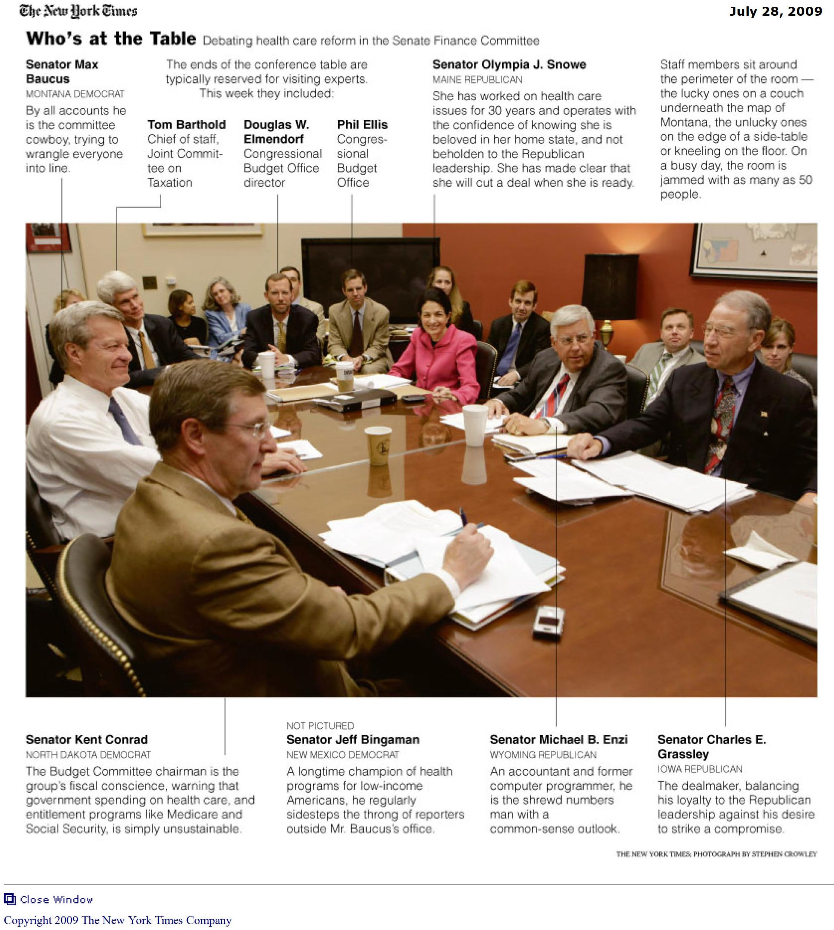以下是參議院財政委員會六人小組2009年7月28]日開會的情形：

財委會主席Baucus在最左側，民主黨三位都在左側(Jeff Bingaman未入鏡)，共和黨三位在對面，Baucus和Olympia Snowe中間的三位是兩院聯合財稅委員會及國會預算局的高級幕僚。

2009年美國出現的茶黨運動，原本係因抗議民主黨國會在2月通過了向企業紓困的經濟刺激法案而來，但醫療改革法案在國會兩院逐步推進，卻使茶黨運動逐漸擴大。7月17日眾院財稅、教育及勞工兩委員會通過醫改案審查報告的同一天，丹佛市KHOW電台談話性節目主持人Ross Kaminsky在其部落格(rossputin.com)上張貼了一張名為「歐巴馬治療即將在你附近的診所服務(ObamaCare coming soon to a clinic near you)」的圖片，將歐巴馬裝扮成一個頭戴羽飾、鼻穿骨飾的非洲巫醫，此一巫醫圖片隨即被許多人以電子郵件轉發，尤其Florida州聖彼得堡(St. Petersburg)的腦神經外科醫師David McKalip轉寄給150人，引起許多自由派部落格譴責其種族歧視。由於McKalip在7月曾組織Florida州茶黨運動抗議歐巴馬醫改案，可推知「歐巴馬治療(ObamaCare)」一語當時已經在茶黨運動參與者之間流傳。

民主黨醫改鎮民大會進入尾聲後，8月28日茶黨運動中一個名為「茶黨快車(Tea Party Express)」組織，開始一項為期半個月的巴士巡迴抗議旅程，自加州首府Sacramento啟程，途經美國南方各州，9月12日到達東岸的華府。在此一名為「收回我們的國家(Take our country back)」的巡迴抗議旅程結束之後，「歐巴馬治療」一詞以及歐巴馬巫醫形象的圖片便明顯出現在茶黨運動中。反對歐巴馬的醫療改革法案，遂逐漸成為茶黨運動主要目標之一，而「歐巴馬治療」這一諷刺甚至帶有種族歧視意味的用語，也逐漸成為媒體與共和黨人對民主黨國會「平價醫療法」的代稱。

六、歐巴馬方案與你說謊

由於財委會六人小組中共和黨保守派Chuck Grassley、Mike Enzi二人與溫和派Olympia Snowe意見分歧，以致小組進展緩慢，跨兩黨支持醫改案協議似乎遙遙無期。白宮方面在九月初開始和Snowe密切聯繫，希望能至少爭取到Snowe支持醫改案、簽署跨兩黨協議，乃至影響到另一位共和黨溫和派參議員Susan Collins (ME)願意支持。尤其重要的是，如能爭取到Snowe的支持，對民主黨內部反對政府公營醫療保險的三位保守派參議員Ben Nelson(NE)、Mary Landrieu(LA)、Blanche Lincoln(AR)的態度必有正面影響。面對政府公營保險選項爭議，Snowe在數月之前提出了所謂「觸發扳機(trigger)」的主張：為了禁止保險公司以個人既往病史為由，拒絕加保，新法中明定一改正(changes)期限，令保險公司必須在期限內改正，以便醫療保險覆蓋人口範圍能擴大，因而降低長期醫療成本。但改正措施如未能於期限內完成，則將「觸發扳機」，創建政府公營保險選項，以迫使保險公司改正。此一「觸發扳機」方案，因小組中共和黨另一議員Mike Enzi反對，並未提至六人小組討論，但白宮九月初聯繫Snowe時，提出了一份比歐巴馬原本醫改構想規模小的醫改案，其中Snowe「觸發扳機」方案已包含在內。

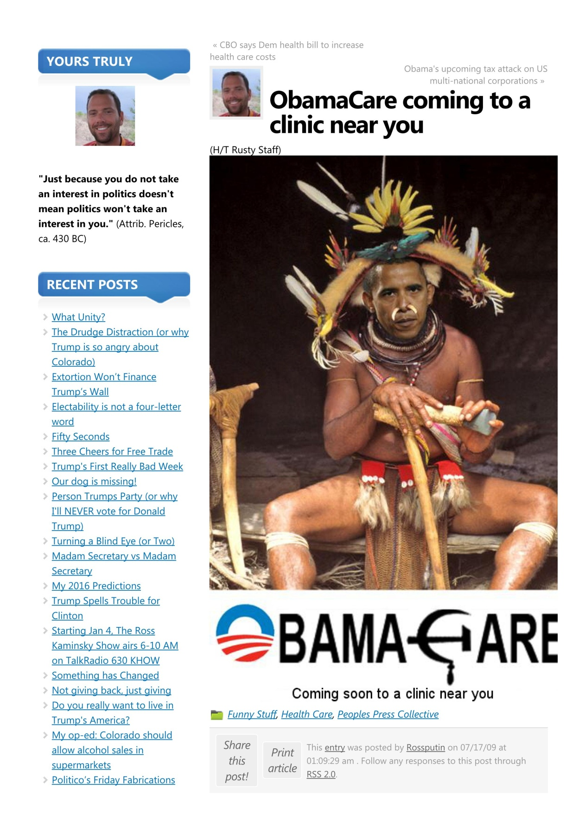

Ross Kaminsky 網頁圖片- ObamaCare coming soon to a clinic near you

資料來源：http://www.rossputin.com/blog/index.php/obamacare-coming-to-a-clinic-near-you

9月8日國會復會，財委會主席Baucus提出了一份醫改立法的折衷架構，並且定下9日上午10:00的最後期限，希望Grassley等共和黨小組成員在9日上午最後期限前能提出相對方案協商。由於歐巴馬總統將於9日晚間到國會發表醫改立法的演說，白宮方面希望六人小組能在歐巴馬演說前，對醫改折衷方案獲致協議。小組民主黨成員Kent Conrad(ND)卻嚴詞批評法案須限期通過的想法，直指「訂下該死的日期或時限的想法…對非常重要的事必定會產生反效果(This idea that there is a drop-dead day or hour is ... absolutely counterproductive to doing something that is critically important)」，而共和黨高階委員Grassley對折衷案更是反應冷淡。Grassley質疑折衷方案中對提供高價位醫療保險的保險公司徵收附加稅的做法，最後只會使保險公司以提高保費的方式將成本轉嫁給消費者。

9日晚間8:00，歐巴馬在國會兩院聯席會議以醫療改革立法為主題，發表演講。白宮也在當天公布了歐巴馬醫療改革的方案(歐巴馬方案：為人人穩定與安全 The Obama Plan: Stability & Security for all Americans)。歐巴馬在演講中一方面讚揚兩院五個委員會在醫改案上的工作表現，一方面指責過去幾個月國會中顯現的黨派性，「某些人深陷於僵硬的意識型態陣營，以致(兩黨)達成協議無望(Some have dug into unyielding ideological camps that offer no hope of compromise)」，其意在譴責六人小組中共和黨的Grassley 與 Enzi二人十分明顯。稍後歐巴馬表示要釐清過去數月來對醫改的傳言誤導，當談到醫改方案將不會使非法移民獲得醫療保險時，共和黨南卡州(South Carolina)眾議員Joe Wilson在台下大喊「你說謊(You lie)」。

Wilson事後向媒體表示，醫改案在眾院三個委員會審查時，共和黨在財稅、能源與商業兩委員會均提出修正案，釐清醫療保險不會將非法移民納入，但兩案均遭民主黨主流否決(少數民主黨委員表決時亦支持修正案)，所以他質疑歐巴馬說謊。當天晚上眾院共和黨領導階層即要求Wilson道歉，Wilson隨後致電白宮，白宮幕僚長Rahm Emanuel在電話中代表歐巴馬接受Wilson道歉。

由於眾議院民主黨內部多人要求Wilson必須另外向眾議院道歉(因兩院聯席會議地點在眾院議場)，而共和黨方面也有眾議員Steve King (Iowa)在黨團中發布公開信，認為總統已接受道歉，敦促Wilson不可再次道歉，道歉與否已經演變為黨派性問題。於是民主黨黨團由多數黨領袖Steny Hoyer(Maryland)在9月15日以眾院權宜問題(Raising a question of the privileges of the House)提案，表達「眾議院不同意Wilson 9月9日在聯席會議中的行為 ( That the House of Representatives disapproves of the behavior of the Representative from South Carolina, Mr. Wilson, during the joint session of Congress held on September 9, 2009.)」的意見。

權宜問題提出一小時後以240比179通過，其中民主黨有12票反對、5票棄權，共和黨則有7票贊成。嚴格而論，此案並未遵循眾院的倫理程序處理，亦未先交付倫理委員會，既非譴責(Censure)亦非申斥(Reprimand)，只是讓Wilson留下了難堪的紀錄。雖然民主黨多數贏得了表決結果，但「你說謊(You lie)」一詞卻成為此後茶黨抗議活動中印刷在汗衫上的醒目標語。

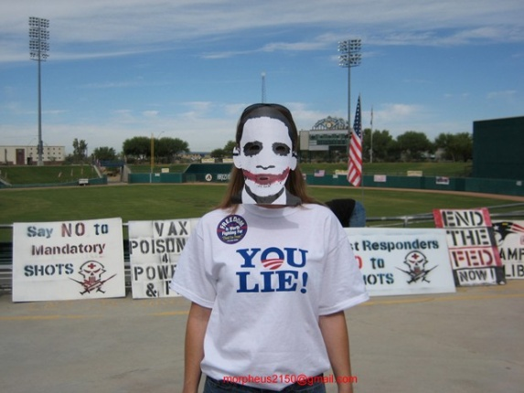 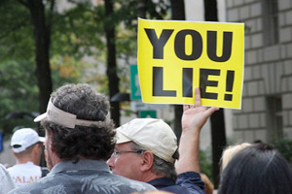 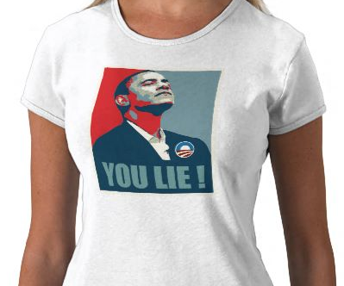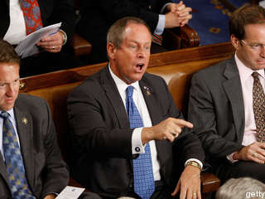

右下圖為Wilson在眾院議場中大喊 “You lie”

[眾院議員不當行為懲處係由倫理委員會Committee on Ethics (原名公務行為標準委員會Committee on Standards of Official Conduct，2011年起改名倫理委員會)管轄，倫理委員會案件處理程序概分為投訴、調查、指控、裁判、量刑(懲處建議)五階段，譴責案係經倫理委員會量刑後向院會提出，須經院會通過，申斥係由倫理委員會通過後向院會報告，二者最大差異在譴責案經院會通過後，該議員須站在議場前方中央主席台前「議場天井(Well)」處，聆聽議長對其宣讀譴責案全文，申斥則無此項羞辱式懲處。]

9月16日參議院財政委員會主席Baucus公布了醫改法草案，Baucus並強調此一版本與歐巴馬總統9月9日兩院聯席會議中提出的架構類似。22日參議院財政委員會開始討論主席Max Baucus版的醫改法案(S.1796 America's Healthy Future Act of 2009)，Baucus版醫改案與兩院其餘四個委員會已經通過的版本不同，其中最大差異即在於沒有政府公營醫療保險選項(public option)的內容，因此相較之下較易為保守派參議員接受(特別是民主黨的保守派選區參議員)。自9月22日起財政委員會先後召開8次條文審查會(markups)，23位委員共提出了564件修正案，10月13日財政委員會以14比9通過本案的委員會報告，一如預期的，共和黨方面僅有參議員Olympia Snowe表決時投下了贊成票，六人小組中其餘Charles Grassley、Mike Enzi二人並未投票支持，這也是平價醫療法立法過程中在參議院唯一的一次共和黨贊成票(Snowe之後在院會表決時並未投贊成票)。

七、啟動核心小組決戰兩院議場

數個月之前，歐巴馬總統特別指派了白宮幕僚長Rahm Emanuel、副幕僚長Jim Messina、總統立法事務助理Phil Schiliro、醫改辦公室主任(醫改沙皇) Nancy-Ann DeParle、白宮聯絡室副主任Dan Pfeiffer、白宮管理及預算局局長Peter R. Orszag組成醫改立法核心小組(core group)。當參院財政委員會通過醫改案委員會報告之後，下一階段醫改案的主戰場將轉移至兩院議場。

接著在參眾兩院各辦公室中發生的內部競賽(inside game)，白宮核心小組開始參與。小組的工作在蒐集情報、評估議員的要求據以設計可能的折衷方案，以爭取那些態度固執的議員支持，不致倒向反對一方。主要目的在使醫改立法的進程，持續在實際可行的軌道上向前推進。簡而言之，目標在如何爭取到最大可能的多數議員最終在表決時投下贊成票，使醫改案能順利通過。

歐巴馬本人在醫改案中亦扮演重要角色，他直接致電那些態度搖擺不定的議員，勸誘他們投票支持，但成功與否仍需視核心小組的談判機智如何而定。核心小組六人則各自有特定的工作重點，幕僚長Emanuel原本為芝加哥(Chicago)選出的眾議員，對國會內部狀況即相當了解，督導核心小組的運作。管理預算局長Orszag是預算熟手，協助在談判中處理最重要而政治敏感的醫改財源問題。醫改沙皇DeParle為醫改團隊中如籃球後衛般掌控全場攻擊的角色，其工作目標在「以白宮助理全面包圍國會(blanketing Congress with White House aides)」。截至2009年10月中旬為止，DeParle個人已經與135位國會議員單獨會商。核心小組與國會議員的會商並非下達白宮命令，醫改沙皇DeParle曾指出：「我們只是給予(黨籍議員)他們某種在黨團內工作的許可執照(we've given them some license to work within their caucuses)」。副幕僚長Jim Messina、總統立法助理Phil Schiliro二人負責與參眾兩院主要的委員會主席聯繫，以確認哪些搖擺不定的議員應由總統致電或歐巴馬親自接見會商。Messina與參議院財政委員會主席Max Baucus關係密切，Messina過去曾擔任Baucus的辦公室主任(chief of staff)；而Schiliro過去也曾擔任眾議院能源與商業委員會主席Henry A. Waxman的辦公室主任。至於聯絡室副主任Dan Pfeiffer，則為醫改案推動過程中的媒體救火隊，2009年8月各地舉行醫改鎮民大會時，白宮承認醫改案已被反對派成功的貼上「政府接管(government takeover)」的標籤，當時歐巴馬醫改方案極可能與1993-1994年間柯林頓總統的醫改計畫最後同樣落敗，Pfeiffer遂開始設計攻擊性的快速反應戰術，白宮運用網路與影片反駁對民主黨醫改目標的錯誤訊息。

八、院會通過與公營醫保差異

10月29日，眾議院民主黨將7月眾院三個委員會各自通過的醫療改革法案整併為一將近2000頁的新議案(H.R.3962 Affordable Health Care for America Act)，仍由John D. Dingell 具名提出。11月7日，眾議院院會討論醫改案(H.R.3962)，規範本案程序的特別規則(H. Res. 903)中，特別准許民主黨議員Bart Stupak提出一項政府公營醫療保險(public option)經費、獲得政府補助的民營保險經費均禁止用於墮胎給付的修正案(H.AMDT.509)。此項反墮胎修正案在晚間10:20以240比194通過，反對票194票均為民主黨領導階層等主流派，而贊成票中除共和黨176票以外亦有64票為民主黨(另有共和黨1票棄權)，清楚顯示歐巴馬與議長Pelosi等高層必須爭取黨內保守派傾向的這64票中至少部分支持，醫改案才可能取得218票過半數通過。

7日深夜11:16全案表決時果然僅以220比215通過，贊成票中僅有一票為共和黨，而反對票除共和黨176票外，仍有39票為民主黨。共和黨投下贊成票者為Louisiana州新任議員Joseph Cao (高光映 Cao Quang Ánh)，高光映為越南裔移民，白宮醫改核心小組幾個月以來即多次與其會商爭取支持，高光映為天主教徒，支持與否癥結一直在反墮胎問題。7日晚間歐巴馬致電高光映游說，當反墮胎修正案表決確定通過後，高光映在最後一刻決定倒戈投下醫改案贊成票。眾議院多數黨領袖Steny Hoyer在記者會中，因這一票而喜形於色的直說這是「跨兩黨表決(bi-partisan vote )」。

參院方面，先前衛生委員會與財政委員會各自通過的醫改案(S.1679、S.1796)，在多數黨領袖Harry Reid主持下，歷經數週的磨合，11月18日Reid公布了整併後2074頁的參議院版醫改提案(H.R. 3590 Amendment in the Nature of a Substitute: Patient Protection and Affordable Care Act)。H.R.3590原係眾議院於10月8日以416比0通過的「軍人購屋稅賦優惠法(Service Members Home Ownership Tax Act of 2009)」，由於醫療改革法案亦具有稅法的性質，必須遵循美國憲法中稅法應由眾議院先提出的程序(因眾議院代表人民、參議院代表各州，政府徵稅應獲得人民代表的同意)，多數黨領袖Reid將醫改案以H.R.3590替代修正案的形式提出，即在於形式上符合稅法應先眾院後參院的憲法規定。除此以外，H.R.3590比眾院11月7日通過的醫改案(H.R.3962)送達參議院的時間要早將近一個月，必須遵循的參院程序規定早已完備(10月13日二讀標題後不經付委，直接編入175號議案日程在院會待審)，方便Reid斟酌實際情形直接提至院會。

11月19日參院多數黨領袖Reid將「進行審議(to proceed to)」H.R.3590一案的程序性動議提出，同時也動議停止討論(cloture) 此一「進行審議」動議。 11月21日停止討論動議以60比39通過，「進行審議」動議亦隨之通過，Reid遂接著將參院版醫改法以H.R.3590替代修正案(S.AMDT.2786)的形式提出。21日停止討論動議的表決顯示，60票完全為民主黨黨團(含Bernard Sanders, Joseph Lieberman 2人)所投，共和黨即使Olympia Snowe也未支持。但是在民主黨本身掌握的60票中，對醫改案實有內部歧見存在。參院醫改法案的關鍵爭議在墮胎給付、醫改新增經費如何籌措、政府公營醫保選項，其中公營醫保選項為最大爭議，參院版公營醫保與眾院不同，允許各州有權利選擇退出(to opt out)，但黨內保守派參議員Mary Landrieu (Louisiana)、Blanche Lincoln ( Arkansas)、Ben Nelson (Nebraska)以及獨立派Joe Lieberman (Connecticut) 等四人均表示反對公營醫保選項，但獨立派Bernie Sanders (Vermont)卻說如果沒有公營醫保選項他將很難支持。

為了解決黨團內部的歧見，由黨團會議副主席Chuck Schumer (New York)領軍，連同另外四位自由派議員Russ Feingold (Wisconsin)、Jay Rockefeller ( West Virginia)、Tom Harkin (Iowa)、Sherrod Brown (Ohio)，會同五位黨內溫和派議員Thomas Carper (Delaware)、Ben Nelson (Nebraska)、Mark Pryor (Arkansas)、Mary Landrieu、Blanche Lincoln等10人閉門會商雙方能接受的折衷方案。12月8日多數黨領袖Reid宣布10人達成了「廣泛共識(broad agreement)」，原本的公營醫保選項，變更為由聯邦人事管理局(federal Office of Personnel Management)監督下的民間非營利組織醫保取代。為了緩和自由派的反彈，並將原本65歲以上的老人醫療保險(Medicare)放寬至准許年滿55歲者可以購買(to buy into Medicare)，此外並將「觸發扳機機制("trigger" mechanism)」納入新方案中，一旦非營利民間保險未來若無法有效的擴大保險人口涵蓋範圍，使成本有效下降時，將使扳機被觸發，創建公營醫保選項。

儘管公營醫保選項已經做了180度大轉彎，但黨內中間偏右社會保守派的Ben Nelson堅決反對將公部門經費用於墮胎給付，Reid 與Schumer除了明確承諾新法中排除墮胎給付之外，並在醫改法案中增訂由聯邦政府無限期100%支付Nelson的Nebraska州擴大低收入戶醫療補助(Medicaid)所需經費(共和黨譏諷為「剝玉米者的退款(Cornhusker Kickback)」)。另一方面黨團中極左的進步派(Progressive) Bernie Sanders對刪除公營醫保選項甚表不滿，於是Sanders的選區Vermont州同樣也在新法中獲得了額外的低收入戶醫療補助經費，並且Sanders最重視的全國性社區保健中心(community health centers nationwide)計畫，也額外在新法中獲得了100億美元。

12月19日協商結果由多數黨領袖Reid具名，以所謂「(議案)管理人修正案(Manager's Amendment)」的形式提出 (S.AMDT.3276 對原替代修正案S.AMDT.2786的修正)。共和黨方面，眼見民主黨內部已經整合完畢，醫改案即將全案通過，遂堅持383頁的「管理人修正案」必須全文宣讀，但此項程序性杯葛亦不過使15位工作人員在19日星期六當天宣讀了7、8小時。為了在12月24日耶誕節前夕全案表決完畢，「管理人修正案」全文宣讀完畢後Reid即提出了分別針對管理人修正案(S.AMDT.3276)、原替代修正案(S.AMDT.2786)、原案(H.R. 3590)的三件停止討論動議。但歐巴馬及Reid此種亟欲快速通過的做法，逼使共和黨原先可能的支持者Olympia Snowe亦公開表示，她已經在19日星期六告知歐巴馬總統，將對醫改案投下反對票。

20日星期日下午1:00參議院繼續開會，管理人修正案(S.AMDT.3276)的停止討論動議在深夜(21日星期一清晨)1:08以60比40通過(vote no.385)，此項表決結果意味醫改案即將在參院順利通過。

22日星期二早晨7:42管理人修正案(S.AMDT.3276)以60比39通過(vote no.387)，緊接著第二個停止討論動議---停止討論「修正後的替代修正案(S.AMDT.2786)」也在7:57以60比39通過(vote no.388)。所謂「修正後的2786號替代修正案」亦即參議院民主黨人最後整合完成的醫改法案， 2786號修正案的表決，其程序上的作用在確定將醫改法案的實質內容，套入原本H.R.3590「軍人購屋稅賦優惠法」的軀殼中。共和黨雖然也自知形勢所迫，根本無力阻擋，仍然在23日針對醫改法案中諸如強制個人需購買保險違憲等問題，提出若干程序性的阻攔，但因民主黨60票團結一致，共和黨也不過稍做拖延而已。23日星期三下午4:01，2786號替代修正案以60比39通過(vote no.394)，H.R.3590正式變更為醫改法案，4:18第三個停止討論動議---停止討論H.R.3590全案也接著通過。

24日星期四已是耶誕節前夕，參議院院會在副總統拜登(Joe Biden)親自主持下，H.R.3590平價醫療法在早晨7:05以60比39通過(vote no.396)。多數黨領袖Reid因過度疲累，唱名表決時先回答「反對(No)」然後才更正為「贊成 (Aye)」。唯一缺席的共和黨Kentucky州參議員Jim Bunning也由黨鞭John Kyl在表決前代為宣布，如出席表決將投反對票。參議員投票後紛紛趕回家鄉過節，耶誕節前夕仍然開會參院並非毫無前例，但上次是在1963年，更早之前是1895年。

2010年民主黨在參議院失去超級多數，必須以預算劃一程序最後完成Obamacare的立法，相關問題下週繼續介紹。

2009年茶黨快車巡迴抗議、共和黨眾議員Joe Wilson “你說謊”、參議院10人幫整合完成等相關新聞片如下：

---------B Tea Party Express

13-12a 20090828 'Tea Party' bus like rock star 1:06 本片暫無字幕檔 13-12a 20090828 spellman.tea.party.bus.tour.cnn_576x324_dl.flv

( CNN's Jim Spellman takes a look at a tour bus that the Tea Party Express is using on its cross-country tour.

• 'Tea Party Express' trucks on with tour aimed at health care )

13-12b 20090904 Tea Party Express 1:32 本片暫無字幕檔 13-12b 20090904 spellman.tea.party.express.cnn_576x324_dl.flv

( All-Platform Journalist Jim Spellman reports on the Tea Party protests across the country. )

13-12c 20090912 D.C. Tea Party wrap 1:28 本片暫無字幕檔 13-12c 20090912 spellman.tea.party.wrap.cnn_576x324_dl.flv

( Protesters angry with the Obama administration hit the streets of Washington, D.C., on Friday to make their voices heard. )

13-12d 20090915 Obama witch doctor image racist? * 2:26

13-12d 20090915 quijano.tea.party.racial.cnn_576x324_dl.flv

( Is the image of President Obama as a witch doctor at tea party protests racist? CNN's Elaine Quijano reports. )

----------C Health Care reform- Joint session

13-12e 20090909 Obama outlines plan * 3:49

13-12e 20090909 obama.healthcare.details.cnn_576x324_dl.flv

20090909 obama.healthcare.details.cnn.doc

( President Obama details the plans under his health-care proposal.

• Obama: 'No one should go broke because they got sick' )

----------D you lie 1

13-12f 20090909 Rep. Wilson heckles Obama * 0:46

20090909 obama.heckled.cnn_576x324_dl.flv

( While defending his health care plan, President Obama is booed, and South Carolina Rep. Joe Wilson shouts "You lie!"

• Obama presents health plan, attacks 'scare tactics' )

13-12g 20090910 Obama accepts apology * 1:52

13-12g 20090910 sot.obama.accepts.apology.cnn_576x324_dl.flv

( President Obama acknowledges the apology of GOP Rep. Joe Wilson of South Carolina after his outburst.

• Obama steps up call for health care reform )

--------B Senate gang of 10 3:47

13-12h 20091209 Health care breakthrough? * 01:26

13-12h 20091209 keilar.health.care.deal.cnn_576x324_dl.flv

( Democrats tout a breakthrough in search for health care plan. CNN's Brianna Keilar reports.

• White House lauds Senate Democrats' health care deal )

13-12i 20091210 Will health care deal hold? * 02:21

13-12i 20091210 bash.senate.healthcare.latest.cnn_576x324_dl.flv

( CNN's Dana Bash reports on the Senate Democrats' tentative deal on health care reform.

• House, Senate health care bills grow further apart )

---------D hurdle cleared 5:23*

--2nd amendment clouture invoked

13-12j 20091219 Democrats get key support * 02:46

13-12j 20091219 bash.health.care.cnn_576x324_dl.flv

( Senate Democrats secure a key vote needed to move health care reform forward. CNN's Dana Bash reports

• Senate Democrats win over key holdouts to reach 60 votes on reform bill )

13-12k 20091221 Health care hurdle cleared [00:14] * 01:54

13-12k 20091221 keilar.senate.heathcare.vote.cnn_576x324_dl.flv

( Health care reform cleared a major hurdle in an early morning vote in the senate. CNN's Brianna Keilar reports.

• Senate health care bill clears key hurdle )

13-12l 20091222 Back-room deals on health bill * 02:23

13-12l 20091222 bash.health.bill.favors.cnn_576x324_dl.flv

( CNN's Dana Bash reports on Democratic leaders' back-room deals to clinch health care reform. )

以下是字幕檔

20090915 Obama witch doctor image racist? 2:26

13-12d 20090915 quijano.tea.party.racial.cnn_576x324_dl.flv

ELAINE QUIJANO, CNN CORRESPONDENT (voice-over): Within the larger Tea Party movement that's gained steam across the country, a small but passionate minority is also voicing what some see as racist rhetoric, including this doctored image circulating on the Internet and even some protesters' signs, like this one in Brighton, Michigan, portraying President Obama as a witch doctor.  
  
We took to the streets of Washington to get reaction.  
  
UNIDENTIFIED FEMALE: I think it's disrespectful to the office of president to portray him in this manner. It's racist.  
  
UNIDENTIFIED FEMALE: This is appalling.  
  
QUIJANO: Just how prevalent were the protesters carrying racially charged messages? Difficult to quantify. CNN all-platform journalist Jim Spellman spent weeks covering the Tea Party demonstrators as a whole.  
  
JIM SPELLMAN, CNN ALL-PLATFORM JOURNALIST: Only a handful of people seemed to outwardly have racial issues with the president. But the more you talk to people, you could sense that it was part of a larger distrust.  
  
QUIJANO: for their part, Tea Party leaders disavowed any racist views.  
  
MARK WILLIAMS, TEA PARTY ORGANIZER: I saw very little overt racism or anger, and those were on the fringes and were marginalized.  
  
QUIJANO: they want attention focused on the role and reach of government into people's lives, but say that controversial protesters have the right to speak their mind.  
  
WILLIAMS: Part of America is that there are people who are bigoted. And, you know, you're never going to convince them not to be. You don't have to embrace them, but in this country, you can't shut them up, either.  
  
QUIJANO: Chicago Tribune columnist Clarence Page sees the Obama presidency as a chance for some to lash out.  
  
CLARENCE PAGE, "THE CHICAGO TRIBUNE": People are not just mad at Obama, they're mad at Jesse Jackson, they're mad at Reverend Wright, they're mad at Al Sharpton, they're mad at people who have nothing to do with Obama, except they all happen to be black.  
  
QUIJANO: Page says the vehemently racial resistance that's emerged is another sign any notion of a post-racial society after Barack Obama's election was wishful thinking.  
  
PAGE: It's only the beginning of the process that we are able to live with leadership that may not look like us, may not come from the same background as us, but is still part of this very diverse society.  
  
QUIJANO (on camera): Mark Williams, the Tea Party organizer we talked to notes there's been inflammatory rhetoric and statements at events like anti-war protests in the past, burning flags and hanging effigies, he says. His point, that like other grassroots movements, the Tea Party protesters are a cross-section of America.  
  
Elaine Quijano, CNN, Washington.

<https://transcripts.cnn.com/show/cnr/date/2009-09-15/segment/01>

*******************

20090909 Obama outlines plan 3:49

13-12e 20090909 obama.healthcare.details.cnn_576x324_dl.flv

Here are the details that every American needs to know about this plan. First, if you are among the hundreds of millions of Americans who already have health insurance through your job, or Medicare, or Medicaid, or the VA, nothing in this plan will require you or your employer to change the coverage or the doctor you have. (Applause.)

Let me repeat this: Nothing in our plan requires you to change what you have.

What this plan will do is make the insurance you have work better for you. Under this plan, it will be against the law for insurance companies to deny you coverage because of a preexisting condition. (Applause.)

As soon as I sign this bill, it will be against the law for insurance companies to drop your coverage when you get sick or water it down when you need it the most. (Applause.)

They will no longer be able to place some arbitrary cap on the amount of coverage you can receive in a given year or in a lifetime. (Applause.)

We will place a limit on how much you can be charged for out-of-pocket expenses, because in the United States of America, no one should go broke because they get sick. (Applause.)

And insurance companies will be required to cover, with no extra charge, routine checkups and preventive care, like mammograms and colonoscopies -- (applause) –

because there's no reason we shouldn't be catching diseases like breast cancer and colon cancer before they get worse. That makes sense, it saves money, and it saves lives. (Applause.)

Now, that's what Americans who have health insurance can expect from this plan -- more security and more stability.

Now, if you're one of the tens of millions of Americans who don't currently have health insurance, the second part of this plan will finally offer you quality, affordable choices. (Applause.)

If you lose your job or you change your job, you'll be able to get coverage. If you strike out on your own and start a small business, you'll be able to get coverage. We'll do this by creating a new insurance exchange -- a marketplace where individuals and small businesses will be able to shop for health insurance at competitive prices.

Insurance companies will have an incentive to participate in this exchange because it lets them compete for millions of new customers. As one big group, these customers will have greater leverage to bargain with the insurance companies for better prices and quality coverage. This is how large companies and government employees get affordable insurance. It's how everyone in this Congress gets affordable insurance. And it's time to give every American the same opportunity that we give ourselves. (Applause.)

********************************

20090909 Rep. Wilson heckles Obama 0:46

13-12f 20090909 obama.heckled.cnn_576x324_dl.flv

BARACK OBAMA, PRESIDENT OF THE UNITED STATES:  
Now, there are also those who claim that our reform efforts would insure illegal immigrants. This, too, is false. The reforms -- the reforms I'm proposing would not apply to those who are here illegally.  
  
(UNKNOWN): That's a lie. [ Rep. Joe Wilson (R-South Carolina): You lie! ]  
  
(AUDIENCE BOOING)  
  
That's not true.  
  
And one more misunderstanding I want to clear up: under our plan, no federal dollars will be used to fund abortions, and federal conscience laws will remain in place.  
  
(APPLAUSE)  
  
Now, my health care proposal has also been attacked by some who oppose reform as a "government takeover" of the entire health care system.

************************************

20090910 Obama accepts apology 1:52

13-12g 20090910 sot.obama.accepts.apology.cnn_576x324_dl.flv

BARACK OBAMA, PRESIDENT OF THE UNITED STATES:

OBAMA: I'm a big believer that we all make mistakes. He apologized quickly and without equivocation. And I'm appreciative of that.  
  
I do think that, as I said last night, we have to get to the point where we can have a conversation about big, important issues that matter to the American people without vitriol, without name- calling, without the assumption of the worst in other people's motives.

We are all Americans. We all want to do best for our country. We've got different ideas, but, for the most part, we have the same aims, which is to make sure that people who work hard in this country and who act responsibly are able to get good jobs, good wages, raise their families, make sure those kids have a good education. That they are protected from misfortune or accident by having health care and retirement security in place. We want to keep people safe, and that's why our national security team is so important.  
  
Our goals are generally the same. Whether we're Democrats or Republicans. And, in fact, most Americans don't even think about those labels all that much. They are turned off when they see people using wild accusations, false claims, name calling, sharply ideological approaches to solve the problems, they want pragmatism. They want people to stay focused on the job and I hope that some of the fever breaks a little bit. The media can always be helpful by not giving all the attention to the loudest or shrillest voices and try to stay a little bit more focused on the issues at hand.

<https://transcripts.cnn.com/show/cnr/date/2009-09-10/segment/04>

******************

20091209 Health care breakthrough? 01:26

13-12h 20091209 keilar.health.care.deal.cnn_576x324_dl.flv

(BEGIN VIDEOTAPE)  
  
SEN. HARRY REID (D), MAJORITY LEADER: We can't disclose the details of what we've done, but believe me we've got something that's good.  
  
KEILAR (voice-over): If it's specifics you're looking for, Senate Majority Leader Harry Reid and the so-called gang of ten senators who negotiated the deal aren't prepared to offer any, not until the Congressional Budget Office puts a price tag on the plan.  
  
REID: We want to know the score before we start giving all the details even to our own members.  
  
KEILAR: Two Democratic sources tell CNN the agreement replaces a public government-run insurance option with a private not-for-profit option. It would overseen by the federal office of Personnel Management, the same group that manages the current health plan for federal employees.  
  
There is a mechanism in the agreement that triggers a more traditional government-run plan if the nonprofit option fails, but the compromise could be a deal-breaker for Wisconsin Senator Russ Feingold. He said last night he would not support replacing the public option with a purely private approach because it wouldn't provide enough competition for insurance companies to keep their rates down.  
  
Sources also tell CNN the deal would allow Americans 55 and older to buy into Medicare. But when reporters press for details late last night, the majority leader was less than subtle about keeping his colleagues silent.  
  
UNIDENTIFIED MALE: The end in sight. Well, I guess --  
  
REID: The answer is yes. OK?  
  
(END VIDEOTAPE)

<https://transcripts.cnn.com/show/ltm/date/2009-12-09/segment/01>

20091210 Will health care deal hold? 02:21

13-12i 20091210 bash.senate.healthcare.latest.cnn_576x324_dl.flv

(BEGIN VIDEOTAPE)  
  
DANA BASH, CNN SR. CONGRESSIONAL CORRESPONDENT (voice-over): Anxious to move forward on his top priority, the president praised a tentative deal to drop a public option from the Senate health care bill.  
  
OBAMA: I support this effort, especially since it's aimed at increasing choice and competition and lowering costs.  
  
BASH: That's the goal of the preliminary agreement, hammered out in secret by 10 Democrats -- five moderates and five liberals. Whether it will hold remains to be seen.  
  
One negotiator is already openly reluctant.  
  
SEN. RUSS FEINGOLD (D), WISCONSIN: I am not happy with the possibility that there would not be a public option.  
  
BASH: Instead of a government-run insurance option, a government agency, the Office of Personnel Management, would oversee not-for- profit private insurance plans. That appeals to moderates.  
  
Democrat sources tell CNN if that plan doesn't work, it would trigger a public option, but that could scare away Joe Lieberman, whose vote Democrats likely need. He issued this statement, underscoring his "opposition to a government-run insurance option, including any option with a trigger..."  
  
To appeal to liberals eager to expand government-run insurance, Democratic negotiators included a huge change in Medicare, allowing uninsured Americans ages 55 to 64 to buy into the program. One estimate says four million people could be eligible. Data on how much it would cost to buy into Medicare under this plan is not yet available, but a recent Congressional Budget Office study on 62-to-64- year-olds put premiums at a whopping $7,600 a year, $634 a month. Democrats say out-of-pocket costs under the plan wouldn't be that high because many people would be eligible for government subsidies starting in 2014. Still, moderate Democrats are wary of adding more strain to already stretched Medicare.  
  
SEN. KENT CONRAD (D), NORTH DAKOTA: The national concern is, what is the effect on Medicare and Medicare solvency, since Medicare is already headed for insolvency?  
  
BASH (on camera): Democratic leaders were clearly eager to show momentum, but several negotiators, both liberals and moderates, say there's no deal yet. They're waiting to hear from Congressional Budget Office to determine how much it will cost and other very important factors. We won't hear from the CBO, according to the Democratic sources, for nearly a week.  
  
Dana Bash, CNN, Capitol HHill.  
  
(END VIDEOTAPE)

<https://transcripts.cnn.com/show/cnr/date/2009-12-10/segment/06>

****************************

20091219 Democrats get key support 02:46

13-12j 20091219 bash.health.care.cnn_576x324_dl.flv

(BEGIN VIDEOTAPE)

DANA BASH, CNN SR. CONGRESSIONAL CORRESPONDENT:   
BASH (voice over): The lone Democratic holdout was in. Senate Democrats finally secured enough votes for health care.  
  
SEN. BEN NELSON, (D) NEBRASKA: Change is never easy. But change is what's necessary in America today, and that's why I intend to vote for closure and vote for health care reform.  
  
BASH: Getting moderate Democrat Ben Nelson's support wasn't easy, especially on the issue of abortion. To reassure him no taxpayer dollars would go for abortion, Democratic leaders struck a deal allowing states to opt out of abortion coverage; and requiring people getting government subsidies to pay for abortion insurance with separate funds.  
  
NELSON: Walls off that money in a very effective manner and makes certain that the plans do not -- we use federal dollars -- we do not use federal dollars to fund abortion.  
  
BASH: Abortion was the final sticking point, but Democratic leaders made several other delicate compromises to get both moderate and liberal Democrats on board. Instead of a government-run health care option, conservative Democrats opposed, the measure sets up not-for- profit private plans, overseen by a government agency, the office of personnel management.  
  
To appease liberals angry about no public option to compete with private insurers, Democratic leaders strengthened regulation on insurance companies, requiring them to spend 80 percent to 85 percent of people's premiums on their medical expenses.  
  
Not all senators who braved blizzard conditions came to celebrate a breakthrough. Republicans accused Democrats of jamming the bill through while Americans are preoccupied with Christmas.  
  
SEN. MITCH MCCONNELL, (R) MINORITY LEADER: In playing these kinds of games with the nation's health care, this is an outrage, and needs to be called that.  
  
BASH: To slow things down -  
  
UNIDENTIFIED FEMALE: Amendments to Subtitle A.  
  
BASH: Republicans forced the Democrats' compromise to be read.  
  
UNIDENTIFIED FEMALE: Two of subsection G of 45-R.  
  
BASH: Out loud, all day long.  
  
The congressional budget office estimates the Senate Democrats' new measure would cost $871 billion over ten years, slightly more than the original bill; and extend health coverage to 30 million people in part by dramatically expanding Medicaid. That was another obstacle in getting Ben Nelson's support who worried about the long-term burden that would put on state budgets. So to secure Nelson's vote, Democrats added a sweetener for his home state, the federal government would pay 100 percent of Nebraska's tab for expanding Medicaid, indefinitely. We asked the Senate majority leader and he described it this way.  
  
SEN. HARRY REID, (D) MAJORITY LEADER: It is compromise. It is -- we worked on different things to get a number of people's votes.  
  
(END VIDEOTAPE)

<https://transcripts.cnn.com/show/cnr/date/2009-12-19/segment/08>

*****************************

20091221 Health care hurdle cleared *[00:14] 01:54

13-12k 20091221 keilar.senate.heathcare.vote.cnn_576x324_dl.flv

(BEGIN VIDEOTAPE)  
  
SEN. JEANNE SHAHEEN (D), NEW HAMPSHIRE: On this vote the yeas are 60, and the nays are 40, 3/5 of the senators duly chosen and sworn, having noted in the affirmative, the motion is agreed to.  
  
BRIANNA KEILAR, CNN CONGRESSIONAL CORRESPONDENT (voice-over): And with that, health care reform cleared a major hurdle in an early- morning vote in the Senate. But for Senate Majority Leader Harry Reid the key breakthrough came on Saturday when Senator Ben Nelson of Nebraska announced that he would back the bill, giving the Democrats 60 votes, the absolute minimum they needed to pass a bill.  
  
SEN. BEN NELSON (D), NEBRASKA: Change is never easy, but change is what is necessary in America today, and that's why I intend to vote for cloture and vote for health care reform.  
  
KEILAR: Nelson signed on only after striking a deal with Democratic leaders to limit insurance coverage of abortions and he offered a warning if that provision is weakened, as the Senate bill is merged with the House passed bill. NELSON: I reserve the right to vote against the next cloture vote if there are material changes to this agreement in the conference report.  
  
KEILAR: Nelson also scored a sweetener for his state. The federal government will pick up the tab for expanding Medicaid in Nebraska, the only state to receive the windfall. While liberal Democrats criticized the bill, which does not include a government-run insurance plan, President Obama praised the compromise.  
  
BARACK OBAMA, PRESIDENT OF THE UNITED STATES: With today's developments, it now appears that the American people will have the vote they deserve on genuine reform that offer security to those who have health insurance and affordable options for those who do not.  
  
KEILAR: Republicans unanimous in their opposition to the Democrat's health care reform bill lambasted it on the Senate floor.  
  
SEN. LINDSEY GRAHAM (R), SOUTH CAROLINA: We will not put the whole nation at risk and take a broken system and make it worse just to get a vote. No way in hell.  
  
(END VIDEOTAPE)

<https://transcripts.cnn.com/show/cnr/date/2009-12-21/segment/01>

*****************************

20091222 Back-room deals on health bill * 02:23

13-12l 20091222 bash.health.bill.favors.cnn_576x324_dl.flv

(BEGIN VIDEOTAPE)  
DANA BASH, CNN SR. CONGRESSIONAL CORRESPONDENT (voice-over): It was a series of backroom deals that secured Ben Nelson's vote, the last Democratic holdout. One sweetener given only to his home state of Nebraska.  
  
Here on page 98 of the compromise, the federal government will pay 100 percent of Nebraska's tab indefinitely for expanding Medicaid for low-income Americans. And when we asked the Democratic leader, he revealed Nelson wasn't the only one getting special deals.  
  
SEN. HARRY REID (D-NV), MAJORITY LEADER: Dana, I would say this -- if you read the bill, which I'm sure you will, you'll find a number of states are treated differently than other states. That's what legislation is all about, compromise. It's compromise. We worked on different things to get a number of people's votes.  
  
BASH: Like Bernie Sanders, the liberal senator was unhappy Democratic leaders dropped a public option and said this a few days ago.  
  
SEN. BERNIE SANDERS (I), VERMONT: It is not for sure that I will vote for that bill.  
  
BASH: Suddenly, his home state of Vermont got some extra help from Medicaid, too. But to clinch Sander's vote, Democrats added his pet project, $10 billion for community health centers nationwide.  
  
SANDERS: One new provision that was placed in the healthcare reform bill by Majority Leader Reid and I want to thank him very much.  
  
BASH: Republicans accuse Democrats of bribery.  
  
UNIDENTIFIED MALE: Chicago-style backroom buy-offs at the expense of the American taxpayers.  
  
UNIDENTIFIED MALE: Sweetheart deals, which make this thing begin to stink to high heaven.  
  
BASH: But Democrats didn't just slip things in to win votes to pass health care. Leading Democrats also added provisions aimed at helping themselves back home. Chris Dodd's support was never in doubt.  
  
SEN. CHRIS DODD (D), CONNECTICUT: This bill is long overdue and critically important.  
  
BASH: But the Connecticut Democrat facing a tough re-election battle buried $100 million in the measure for a new hospital. Other states can compete for it, but he put it in hoping Connecticut gets the hospital.  
DODD: It doesn't involve just my state, although my state is very interested.  
  
BASH (on camera): And it doesn't stop there. Lots of other senators are getting different things for their states, like there's extra Medicare funding for states like Montana, South and North Dakota. And the Senate majority leader is unapologetic about it.  
  
He says it's just the way things are. In fact, he also said, "I don't know if there's a senator that doesn't have something important to it to them. If they don't," he said, "it doesn't speak well of them."  
  
Dana Bash, CNN Capitol Hill.  
  
(END VIDEOTAPE)

<https://transcripts.cnn.com/show/cnr/date/2009-12-22/segment/03>